This resource contains two items: a blank template, and a sample of two must-haves for a general role.

Planning for Must-Haves at Each Stage — Template
We promised your time spent on Figuring Out the Role and creating must-haves would pay off! Now, use this worksheet to plan how you’ll test and evaluate the must-haves at each stage of the hiring process. Keep in mind—you don’t have to test for every must-have at every stage, though most interview questions and simulations will surface multiple must-haves. By the final stages, test for the qualities or skills you haven't seen yet.
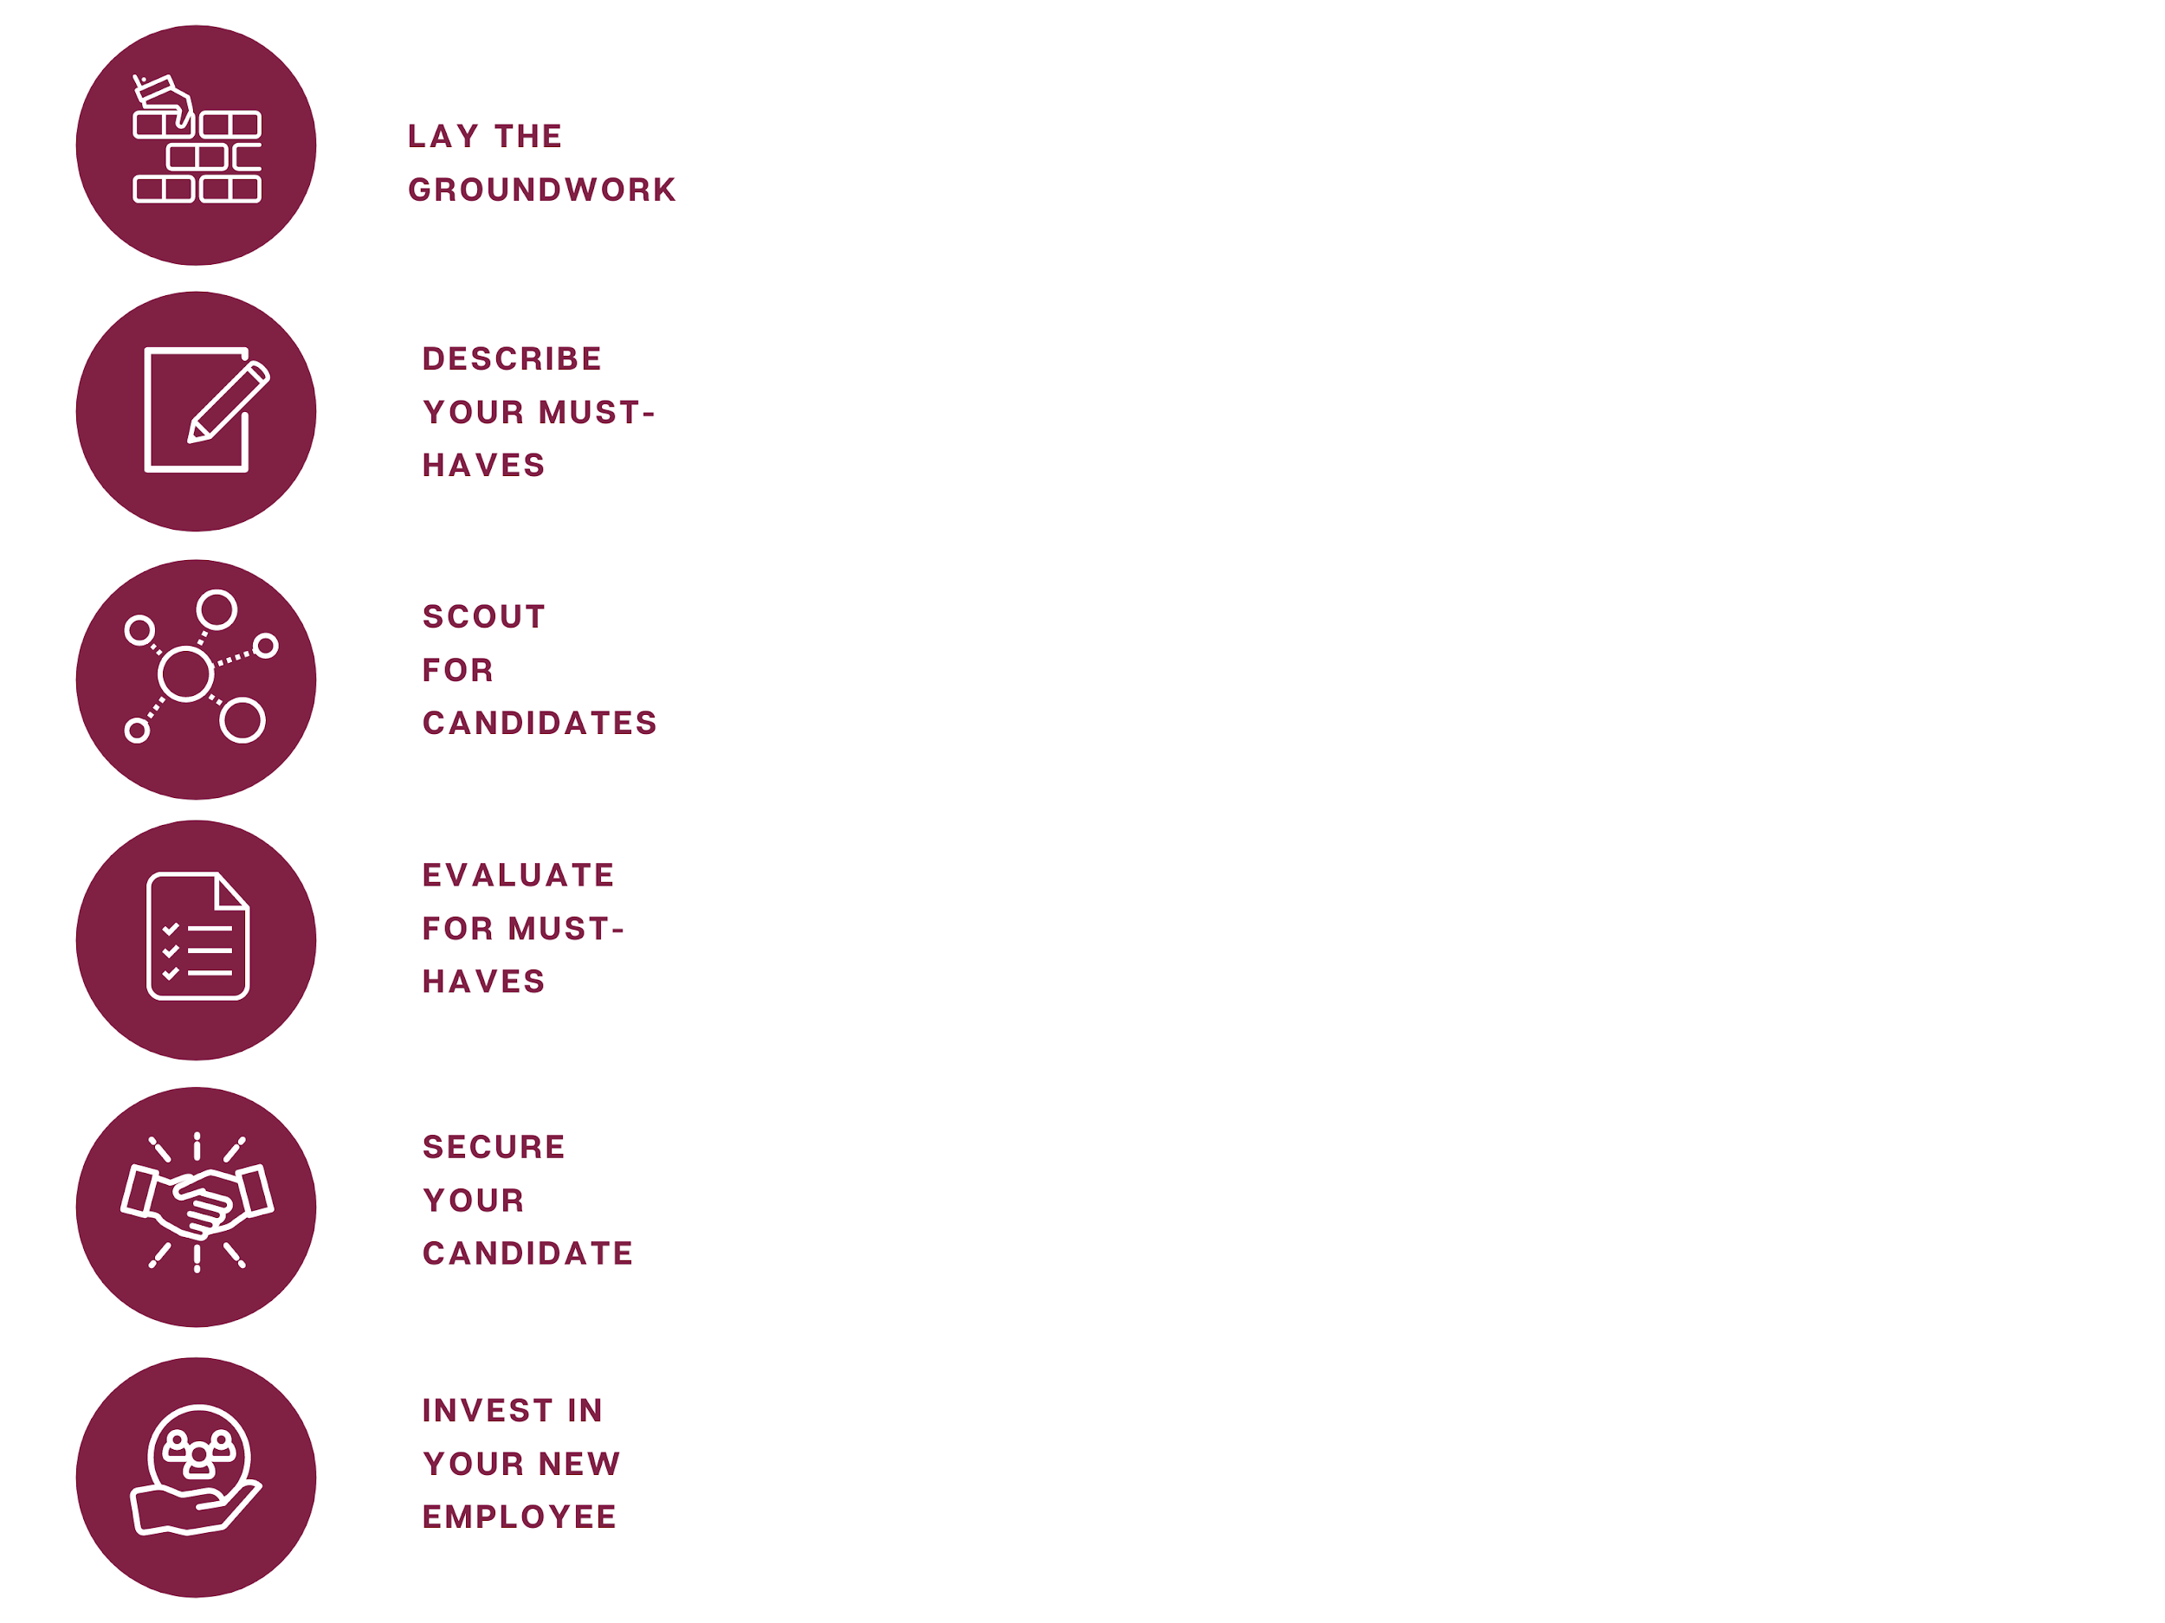
Must-Have | Job Announcement | Interviews* | Simulations / Exercises* | Reference Checks
1. |  | Q1.  Q2.  Q3. | S1.  S2. | Q1.  Q2.  Q3.
2. |  | Q1.  Q2.  Q3. | S1.  S2. | Q1.  Q2.  Q3.
3. |  | Q1.  Q2.  Q3. | S1.  S2. | Q1.  Q2.  Q3.
4. |  | Q1.  Q2.  Q3. | S1.  S2. | Q1.  Q2.  Q3.
*Consider sending 1-2 interview questions or exercises in advance. This gives candidates time to prepare. Also, consider compensating people if the exercise asks candidates to invest a lot of time or produce a real-world product.

Planning for Must-Haves at Each Stage — Admin Sample

Must-Have | Job Announcement | Interviews | Simulations / Exercises | Reference Checks
Must-Have #1. Highly organized, motivated, and detail-oriented  Manages a high volume of work with efficiency: Has, or can create, a system for keeping tasks from slipping through the cracks. Able to juggle competing demands and prioritize without sacrificing quality. Plans ahead to make deadlines. Asks for help when needed.  Strong sense of ownership and attention to detail: Notices and fixes errors that others might overlook. Acknowledges mistakes and turns them into learning opportunities. Has a track record of leaving things better than they found them. | You are highly organized and detail-oriented. You enjoy building or maintaining systems that help you—and others—stay organized. You can manage a high volume of work because you always plan ahead, troubleshoot, and keep track of details. You catch and fix errors (because nobody is perfect, including you) and turn mistakes into learning opportunities. Because of this, you have a track record of leaving things in better shape than you found them. | Q1. How do you decide what to spend your time on in a given day?  Look for: Strategic prioritization.  Q2. Tell me about a time when you had a tight deadline. What was the project? How did you get everything done? How did you engage with others to ensure a diversity of perspectives?  Look for: Able to plan and prioritize under pressure. Nice-to-have: Asks for help/informs others.  Q3. Share a scenario in advance: It’s almost the end of the day. You have been handling logistics for tomorrow’s event and you just heard there is a storm with potential floods expected. Come up with 3-5 ideas and one main recommendation you’d share with your manager for how to handle this.  Look for: Solid troubleshooter. Strong sense of ownership. | S1. Provide candidates with an example of how a shared resource is organized now (e.g. student resource center, staff supply closet, spreadsheet, or filing system). Ask for 3 ideas to improve the system. Describe who uses the system. Provide a budget, if relevant.  Look for: Able to create/improve organizational systems. Attention to detail. Nice-to-have: Asks questions.  S2. Invite candidates to spend no more than [X time] developing a project plan relevant to the role. Describe basic considerations or parameters (purpose, outcomes, audience, typical length or timeline), while leaving enough room to see how well the candidate knows the terrain and makes independent choices.  Look for: Clear, thorough planning. Well-organized information with few errors. | Reference checks should focus on the qualities you haven't seen yet or most want to confirm, along with questions that help you get ready to manage well. For example:  Q1. One skill needed for this role is managing a large volume of work. Can you talk about a time that the candidate demonstrated this skill? How well did they get everything accomplished? Did they meet your goals or expectations?  Q2. Tell me about a time when [candidate name] made a mistake at work. How did they respond? How could you tell if they learned from this experience?

Planning for Must-Haves at Each Stage — Admin Sample continued

Must-Have | Job Announcement | Interviews | Simulations / Exercises | Reference Checks
Must-Have #2. Relationship builder  Attentive, empathetic leadership: Enthusiasm for meeting and engaging with people. Empathizes with the communities we serve. Able to put people at ease, especially when there are lines of difference. Listens closely to understand needs or concerns, and takes steps based on that input. Gets back to people in a timely manner. Takes pride in providing clear, helpful information.  Realness: Comes across as genuine. Says what they mean. Builds authentic relationships across lines of difference, such as race, ethnicity, sexual orientation, class, ability, gender identity, citizenship status, or other identities. Follows through on commitments.  Now, add more must-haves and brainstorm ways you’ll test them! | You believe in our mission and the communities we serve. You listen closely for the need underneath the complaint or concern, and work collaboratively to devise solutions. You spot barriers and have a superpower for making services or programs easier to access and more relevant. You welcome feedback from colleagues and the people you support, and you work to integrate new ideas. When you have feedback or information for others, you aim to be clear and helpful. Because of all this, you build authentic relationships with others (internally and externally) based on mutual trust and respect, especially and including when there are lines of difference (across race, ethnicity, status, sexual orientation, ability, or gender identity) involved. | Q1. When you started your previous job, how did you approach building relationships across lines of difference and power (externally and internally)? How did your own identities influence your approach? Tell us about an example of a time when your relationship-building led to a more effective, equitable, or sustainable outcome.  Look for: Prior successful experience building trust.  Q2. Tell us about a time you worked to address someone’s concern and you weren’t able to. What happened? What did you do? Were there lines of difference or power that made this tricky? What might you do differently next time?  Look for: Empathizes. Listens for needs. Tries to resolve problems. | S1. Choose a common task associated with this role (e.g., calling parents, reminding colleagues to get their reimbursements in). Create a mock email or call from someone they’d have to engage with who might be frustrated or anxious. Ask the candidate to write or record a reply showing how they would help the person.  Look for: Puts others at ease. Designs solutions. Provides clear information.  S2. Do a role play where a colleague shares a differing perspective on an issue and ask the candidate to engage (e.g., by asking questions and seeking clarity).  Look for: Deep listening. Respect for different perspectives. Nice-to-have: Integrates new ideas. | Q1. At [name of your organization], we really value going above and beyond to help members and remove barriers to participation or access. How have you seen the candidate demonstrate this value in your work together?  Q2. A big part of the job is being able to build authentic relationships with the communities we serve including [be explicit about the race, age, language, and other identities of your constituents]. Have you seen the candidate listen well, show empathy, or build mutual respect with others? How well do you think they navigated this? What was their approach? What went well or could have been better?

