Defining Your Approach Worksheet

Delegating well requires clearly defining success and expectations, staying engaged, and creating accountability—all while adapting to fit the context. Use this worksheet to decide your approach to staying engaged.

Questions to reflect on for assessing context:
- Staff-person skill, will, and capacity. How motivated is the staff person to do the project? What is their capacity in terms of time and energy?
- Your capacity. How much time, energy, and willingness do you have to support them?
- Importance and complexity. How high-stakes is this project? How does it compare to your organizational or departmental priorities? How many stakeholders are involved? How much of the work is new or unpredictable? How high-quality does the work need to be?
- External circumstances. What else is happening within the organization or in the world that might affect your staff’s ability to complete the project successfully? What support might they need from you?

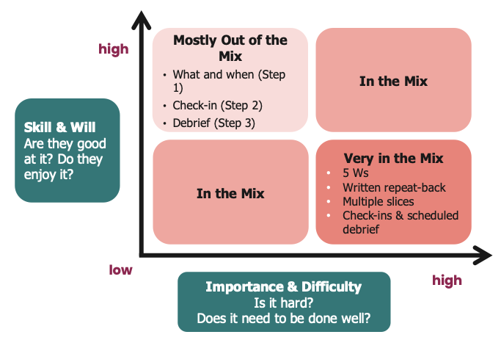

Project / Task:  What does success look like? | Owner | Define your approach | Specific activities for how you’ll stay involved
 |  | Very in the mix
 |  | In the mix
 |  | Mostly out of the mix

Sample
This is a sample of the Defining Your Approach worksheet filled out by an Executive Director for a few major work streams associated with end-of-year planning.

Project / Task:  What does success look like? | Owner | Define your approach | Specific activities for how you’ll stay involved
Crafting next year's budget proposal for winter board meeting. Should be ambitious (growth from this year) but achievable (clear, feasible revenue generation plan), and reflect org priorities and values. | Jorge | Very in the mix | - Provide feedback on plan to engage department heads  - Follow up with department heads who are late with proposals if needed  - Meet with Jorge 2x/week for updates on progress and troubleshooting issues  - Review and give feedback on draft budget proposals
Running EOY fundraising drive. We meet our fundraising goals, including 40% of revenue coming from small donors. | Angela | Mostly out of the mix | Periodic check-ins with Angela and making myself available to her as needed.
Setting next year's political goals. We advance our major political priorities and secure major wins for low-income and BIPOC residents of our state. Our goals are informed by our membership. | M | In the mix | - Check in weekly with M  - Support planning, recruitment, and strategy for People’s Assembly through additional workblocks as needed

